

08

Fall

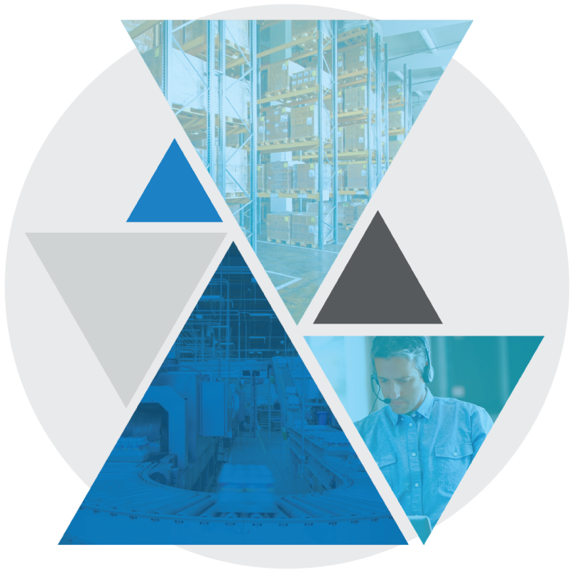

**Test Case: BASE-LDG-0010**

**Terminal Outbound Loading LTL Directed**

Table of Contents

Terminal Outbound Loading LTL Directed 3

Test Case Setup 3

Test Case Cleanup 3

Test Case Prerequisites and Assumptions 4

Test Case Examples 4

Test Case Configurations 5

Test Case Verification Approach 5

Test Case Specification 5

Terminal Outbound Loading LTL Directed

This document documents the test case instructions for the BASE-LDG-0010 Bundle Test Case implementing Terminal Outbound Loading LTL Directed.  
  
**Please note**: The inputs used in these test case specifications (defined in the input CSV files or Datastore) are relative to our testing warehouse environment and are provided as examples. These inputs should be substituted with valid inputs relative to your WMS environment.

Test Case Setup

* Test Case Background function will run the standard set of setup scenarios for the bundle.
* Test Case Dataset
  + Create a trailer and accompanying variables required to check it in
  + Create variables required for a shipment and carrier move

Test Case Cleanup

* The Test Case After Scenario will run the standard cleanup actions for the bundle.   
  **NOTE:** This including logging out of all interfaces (Terminal and Web).
* Data created during dataset creation and execution is cleaned up.

Test Case Prerequisites and Assumptions

* Environment is configured for function

Test Case Examples

This Test Case will only perform Terminal Outbound Loading LTL Directed and will not perform any other examples.

Test Case Configurations

The Test Case will be run in the following test configurations:

* Narrow Terminal
* Wide Terminal

Test Case Verification Approach

This test will verify screen data in-line within the test step sections.

It will also Utilize a MSQL WMS query to validate that the anticipated end state was reached.

Test Case Specification

|  |  |
| --- | --- |
| **Test Case:** BASE-LDG-0010 Terminal Outbound Loading LTL Directed | **Description:** Terminal Outbound Loading LTL Directed **Functional Area:** Loading **Test Case Type:** Regression **Dataset:** Datasets/Base/Web_Outbound_Trailer_Common **Test Case Inputs:** Test Case Inputs/BASE-LDG-0010.csv **Duration:** 2 minutes |

|  |  |
| --- | --- |
| **Steps, Actions, and Expected Results** | **Supporting information and/or Affected Data** |
| **Step 1**: Login to Terminal  **Actions**:   * Enter into the terminal a valid ID * Click ENTER * Enter into the terminal appropriate User ID and Password * Click ENTER * Enter into the terminal appropriate Work Information data   **Expected Results**:   * User is successfully logged in and is at the Undirected Menu |  |

|  |  |
| --- | --- |
| **Step 1**: Navigate to the *Directed Work* screen  **Actions**:   * Press ‘9’   **Expected Results**:   * User is on the *Directed Mode* screen |  |

|  |  |
| --- | --- |
| **Step 2**: Confirm Load Equip  **Actions**:   * Press ENTER   **Expected Results**:   * User is on *Confirm Workflow* screen |  |

|  |  |
| --- | --- |
| **Step 3**: Perform trailer safety check  **Actions**:   * Press ENTER to begin test * Press ‘Y’ to confirm Nose stand * Press ‘Y’ to confirm Is the trailer clean * Press ‘Y’ to confirm Ceiling/Walls/Floor OK   **Expected Results**:   * User is on *Loading Pickup* screen |  |

|  |  |
| --- | --- |
| **Step 4**: Enter in LPN  **Actions**:   * Type in valid LPN (**F3** will generate an LPN) * Press ENTER   **Expected Results**:   * User is on *Loading Deposit* screen |  |
| **Step 5**: Enter in Dock location  **Actions**:   * Type ‘CYC_SDCK_077’ (defined in input file) * Press ENTER   **Expected Results**:   * User is on *Directed Mode* screen temporarily |  |

|  |  |
| --- | --- |
| **Final State:** User is on *Directed Mode* screen  Test verification and log off scenarios are performed |  |